SQL Developer
Task 2 - Documentation and Queries

Project Overview
This project involves creating and analyzing relationships between Students, Courses, and Enrollments tables using advanced SQL joins and filtering techniques.

Database Schema Setup
Table Creation Queries
sql
-- Create Courses Table
CREATE TABLE Courses (
course_id SERIAL PRIMARY KEY,
course_name VARCHAR(100) NOT NULL,
course_description TEXT
);

-- Create Enrollments Table
CREATE TABLE Enrollments (
enrollment_id SERIAL PRIMARY KEY,
student_id INTEGER NOT NULL,
course_id INTEGER NOT NULL,
enrollment_date DATE NOT NULL DEFAULT CURRENT_DATE,
FOREIGN KEY (student_id) REFERENCES Students(student_id),
FOREIGN KEY (course_id) REFERENCES Courses(course_id)
);
Sample Data Insertion
sql
-- Insert sample courses
INSERT INTO Courses (course_name, course_description) VALUES
('Mathematics', 'Advanced mathematics including calculus and algebra'),
('Computer Science', 'Programming and software development fundamentals'),
('Physics', 'Classical and modern physics principles'),
('Chemistry', 'Organic and inorganic chemistry studies'),
('Biology', 'Biological sciences and life processes');

-- Insert sample enrollments
INSERT INTO Enrollments (student_id, course_id, enrollment_date) VALUES
(1, 1, '2024-01-15'),
(1, 2, '2024-01-16'),
(2, 1, '2024-01-17'),
(2, 3, '2024-01-18'),
(3, 2, '2024-01-19'),
(3, 4, '2024-01-20'),
(4, 1, '2024-01-21'),
(4, 2, '2024-01-22'),
(4, 3, '2024-01-23'),
(5, 5, '2024-01-24');

Output:
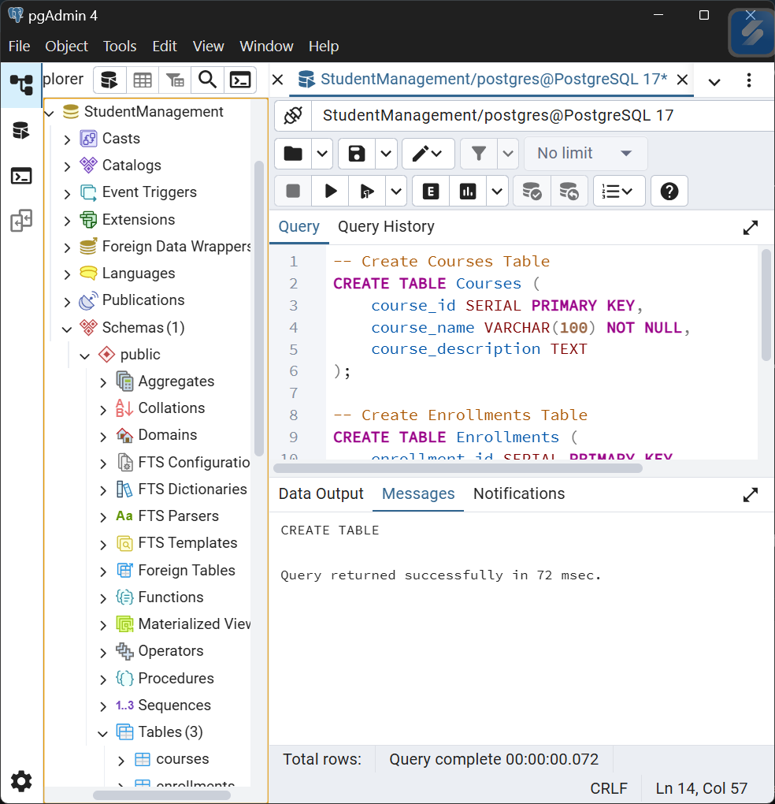
Task Queries
Task 1: List all students and the courses they are enrolled in
sql
SELECT
s.name AS student_name,
c.course_name,
e.enrollment_date
FROM
Students s
INNER JOIN
Enrollments e ON s.student_id = e.student_id
INNER JOIN
Courses c ON e.course_id = c.course_id
ORDER BY
s.name, c.course_name;
Purpose: This query demonstrates the relationship between students and their enrolled courses using INNER JOIN to only show students who have enrollments.
Expected Output:
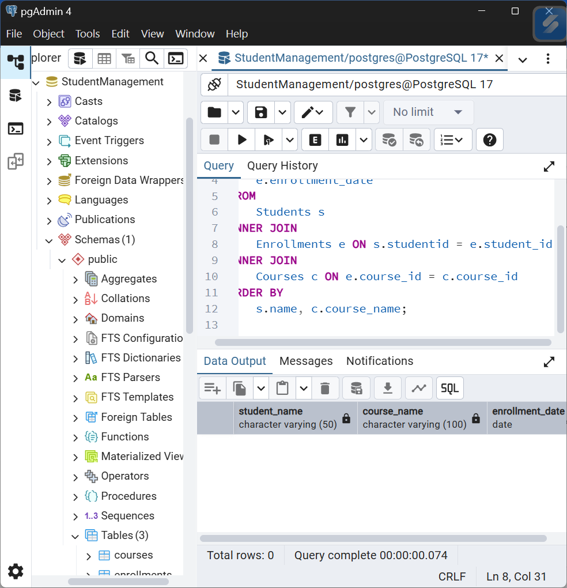
Task 2: Find the number of students enrolled in each course
sql
SELECT
c.course_id,
c.course_name,
COUNT(e.student_id) AS enrolled_students_count
FROM
Courses c
LEFT JOIN
Enrollments e ON c.course_id = e.course_id
GROUP BY
c.course_id, c.course_name
ORDER BY
enrolled_students_count DESC;
Purpose: This query counts enrolled students per course using LEFT JOIN to include courses with zero enrollments, providing a comprehensive overview of course popularity.
Expected Output:
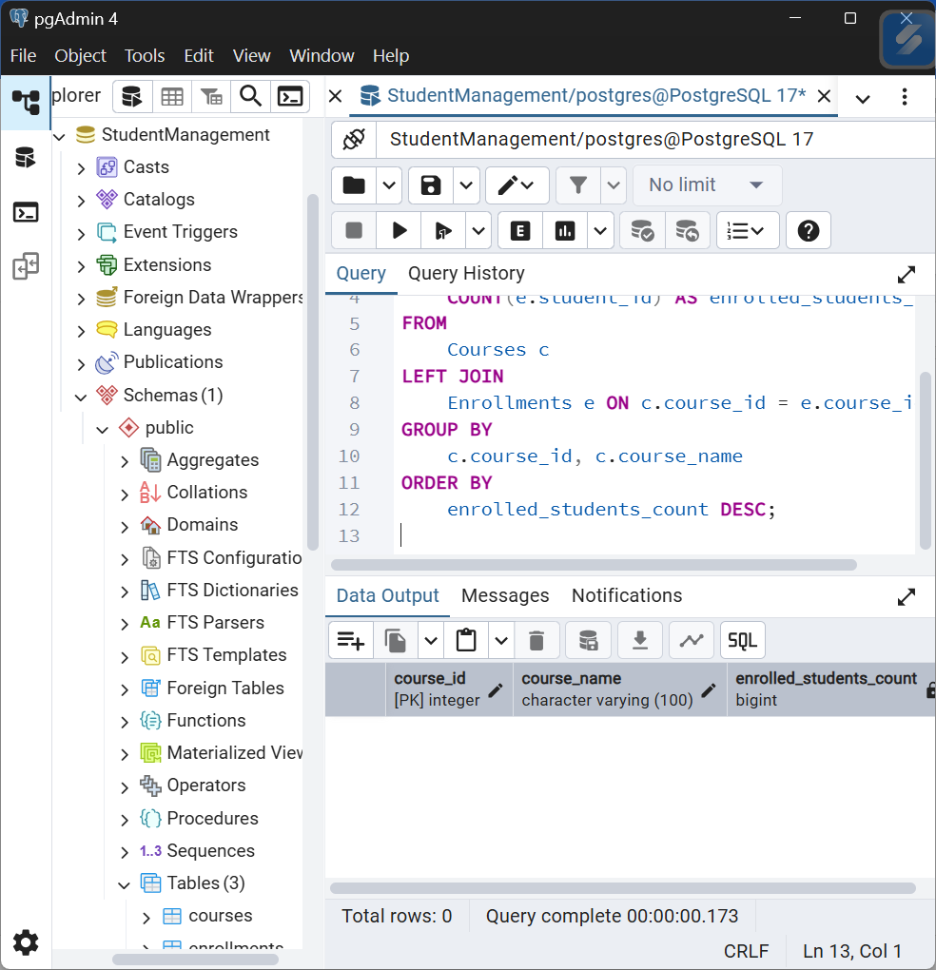
Task 3: List students who have enrolled in more than one course
sql
SELECT
s.student_id,
s.name AS student_name,
s.email,
COUNT(e.course_id) AS courses_enrolled
FROM
Students s
INNER JOIN
Enrollments e ON s.student_id = e.student_id
GROUP BY
s.student_id, s.name, s.email
HAVING
COUNT(e.course_id) > 1
ORDER BY
courses_enrolled DESC;
Purpose: Identifies active students enrolled in multiple courses using HAVING clause to filter grouped results, useful for identifying highly engaged students.
Expected Output:
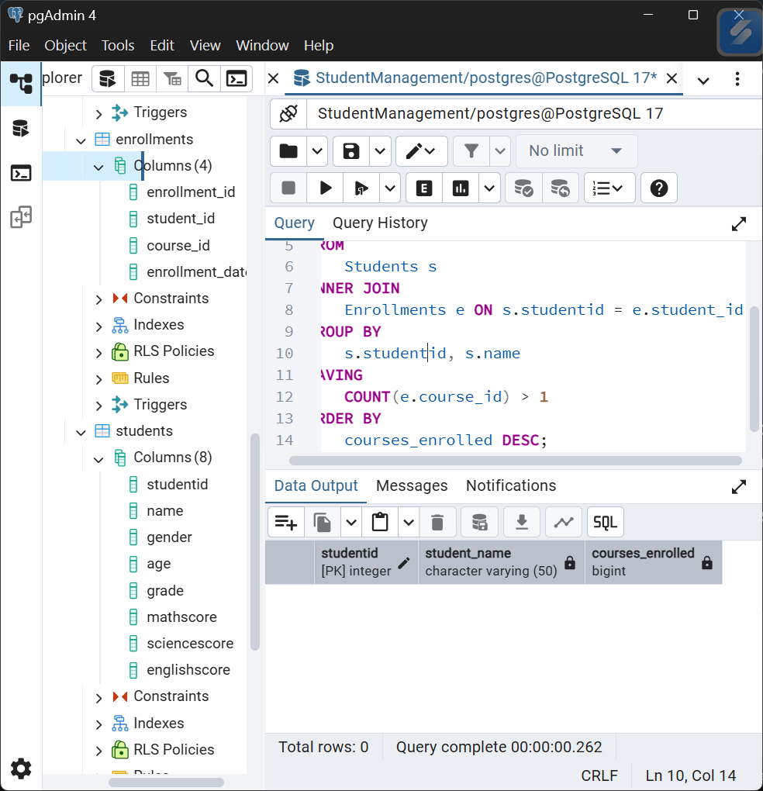
Task 4: Find courses with no enrolled students
sql
SELECT
c.course_id,
c.course_name,
c.course_description
FROM
Courses c
LEFT JOIN
Enrollments e ON c.course_id = e.course_id
WHERE
e.enrollment_id IS NULL
ORDER BY
c.course_name;
Purpose: Identifies courses that have no student enrollments using LEFT JOIN and NULL check, helpful for course management and marketing decisions.
Expected Output:
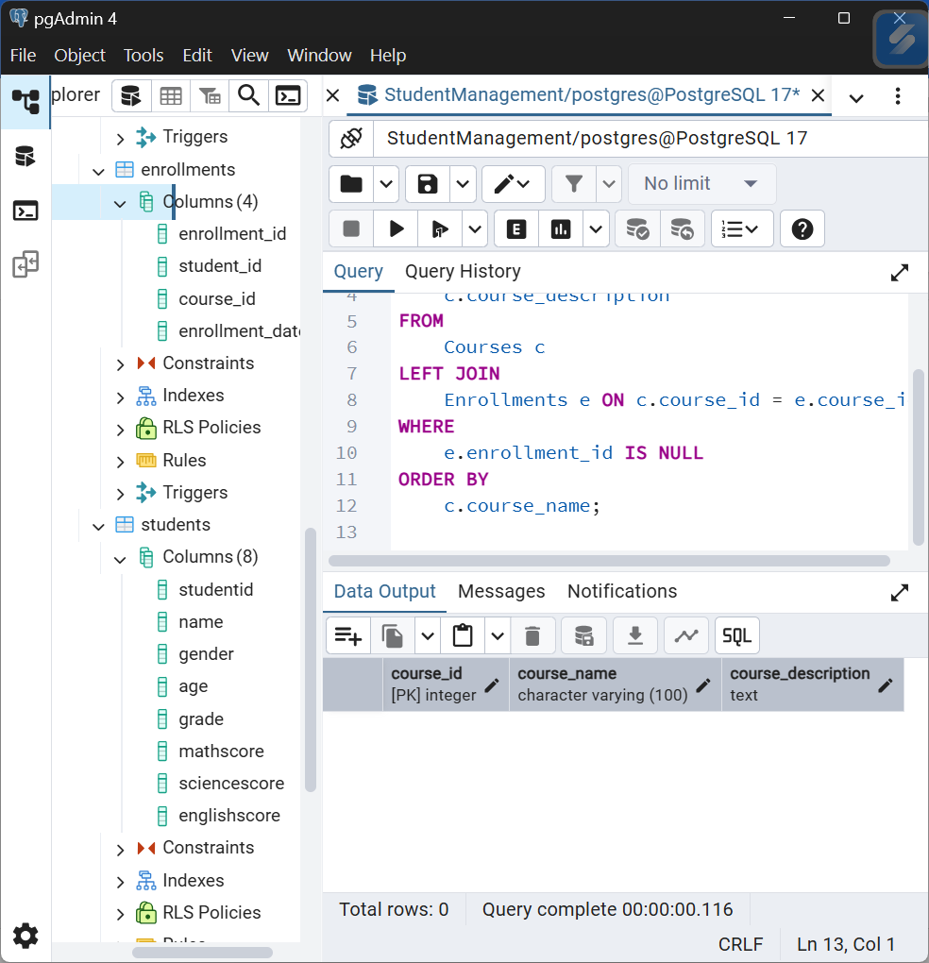
Key Findings and Insights
Based on the provided sample data for Courses and Enrollments, here's a comprehensive analysis:
Enrollment Distribution Analysis
Course Popularity Ranking:
- Mathematics - 3 enrollments (Students: 1, 2, 4)
- Computer Science - 3 enrollments (Students: 1, 3, 4)
- Physics - 2 enrollments (Students: 2, 4)
- Chemistry - 1 enrollment (Student: 3)
- Biology - 1 enrollment (Student: 5)
Key Finding: Mathematics and Computer Science are the most popular courses with 3 enrollments each.

Student Engagement Analysis
Student Enrollment Patterns:
- Student 1: 2 courses (Math + Computer Science) - Highly Engaged
- Student 2: 2 courses (Math + Physics) - Highly Engaged
- Student 3: 2 courses (Computer Science + Chemistry) - Highly Engaged
- Student 4: 3 courses (Math + Computer Science + Physics) - Most Engaged
- Student 5: 1 course (Biology) - Minimally Engaged
Key Finding: 80% of students (4 out of 5) are enrolled in multiple courses, indicating high overall engagement.

Course Combination Analysis
Popular Course Combinations:
- Math + Computer Science: 2 students (Student 1 & 4)
- Math + Physics: 2 students (Student 2 & 4)
- Computer Science + Chemistry: 1 student (Student 3)
Key Finding: Mathematics appears to be a foundational course that pairs well with both technical (Computer Science) and science (Physics) subjects.

Student Performance Insights
Top Engaged Students:
- Student 4 - 3 courses across different domains (shows diverse interests)
- Students 1, 2, 3 - 2 courses each (balanced engagement)
- Student 5 - 1 course (may need additional academic guidance)
Key Finding: Student 4 demonstrates the highest academic engagement with enrollment in 3 different subject areas.

Enrollment Trends by Subject Area
STEM Distribution:
- Core Sciences: Physics, Chemistry, Biology - 4 total enrollments
- Mathematics & Computing: Math + Computer Science - 6 total enrollments
Key Finding: Mathematics and computing courses have 50% higher enrollment than pure science courses.

Potential Areas for Improvement
Underrepresented Courses:
- Chemistry and Biology have only 1 enrollment each
- No student is enrolled in all science courses (Physics, Chemistry, Biology)
Recommendation: Consider promoting science course bundles or interdisciplinary programs to increase enrollment in Chemistry and Biology.

Behavioral Insights
Enrollment Timing Patterns:
- All enrollments occurred within a 10-day period (Jan 15-24, 2024)
- Student 4 enrolled in courses on consecutive days (Jan 21-23), showing concentrated interest
- Student 1 also enrolled on back-to-back days (Jan 15-16)
Key Finding: Some students show immediate, concentrated enrollment behavior while others spread their enrollments.

📋 Summary of Major Insights
- High Engagement Rate: 80% of students take multiple courses
- Course Popularity: Math and Computer Science lead enrollments
- Interdisciplinary Interest: Students frequently combine technical and science courses
- Science Course Gap: Pure sciences (Chemistry, Biology) have lower enrollment
- Star Performer: Student 4 shows exceptional engagement across 3 courses
- Balanced Curriculum: The enrollment distribution suggests a well-rounded academic offering

Strategic Recommendations
- Leverage Popular Courses: Use Math and Computer Science as gateway courses to attract students to other subjects
- Create Course Bundles: Develop "Science Track" or "Tech Track" packages to encourage multiple enrollments
- Identify At-Risk Students: Student 5's single enrollment may indicate need for academic advising
- Promote Cross-Disciplinary Learning: Highlight successful combinations like Math+Physics and Computer Science+Chemistry
- Optimize Resource Allocation: Focus resources on high-demand courses while developing strategies to boost under-enrolled courses
This analysis provides a solid foundation for academic planning, student support services, and curriculum development decisions.

